**Verification Plan for ITCB Application**

**Log4j-2 changes**

* Check - application is up & running.

As we have made the required changes for log4j2 in log4j2.properties file and in the classes wherever its needed in the IDVS code. Now run the application at local space.

Login page will be visible for this app.

Now you can login and move forward with the verification of application.

Simultaneously capture the artifacts for proof.

* Artifacts:

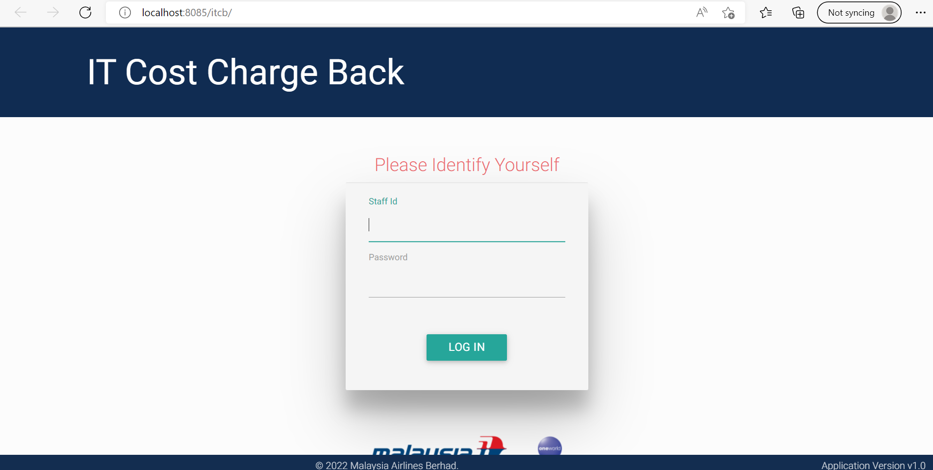

* Application Login is working fine.

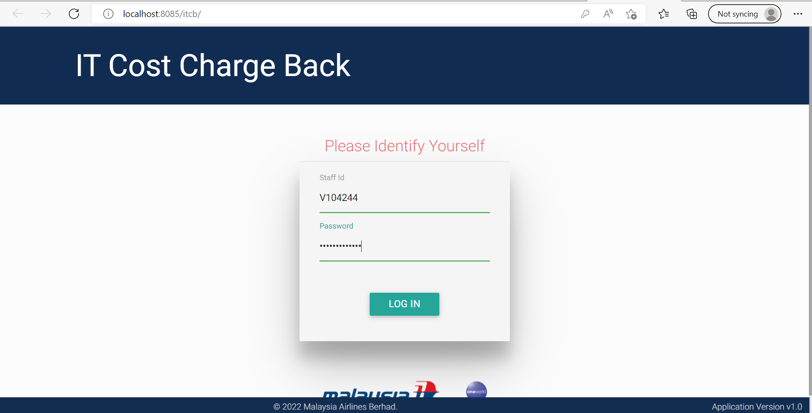

* Released functionality/Basic functionality.
* Home page - after login is successful

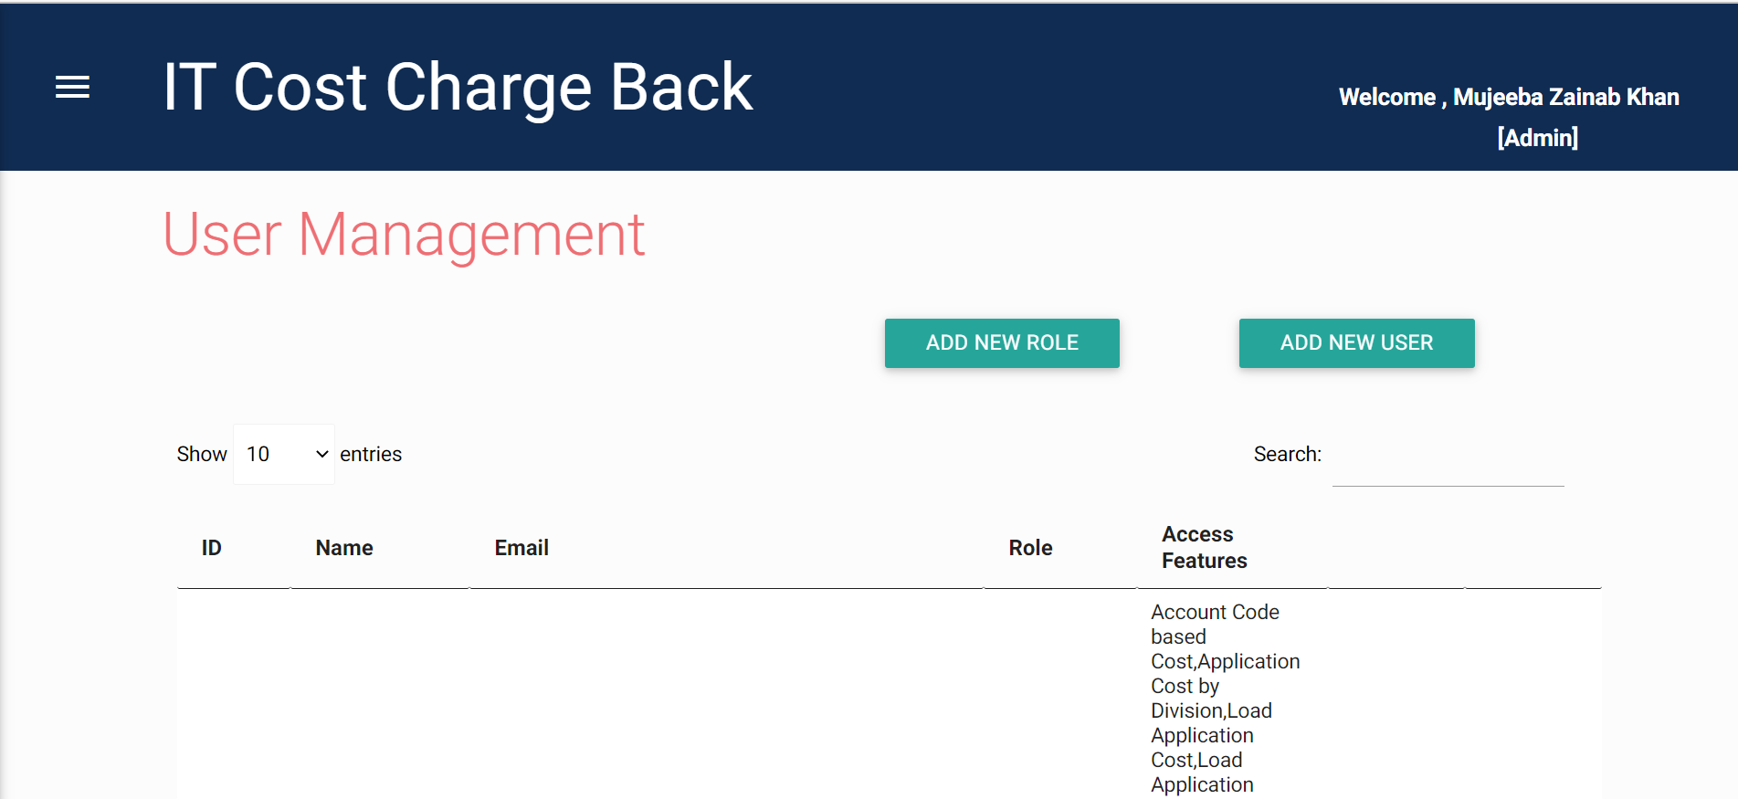

* Application Cost Template

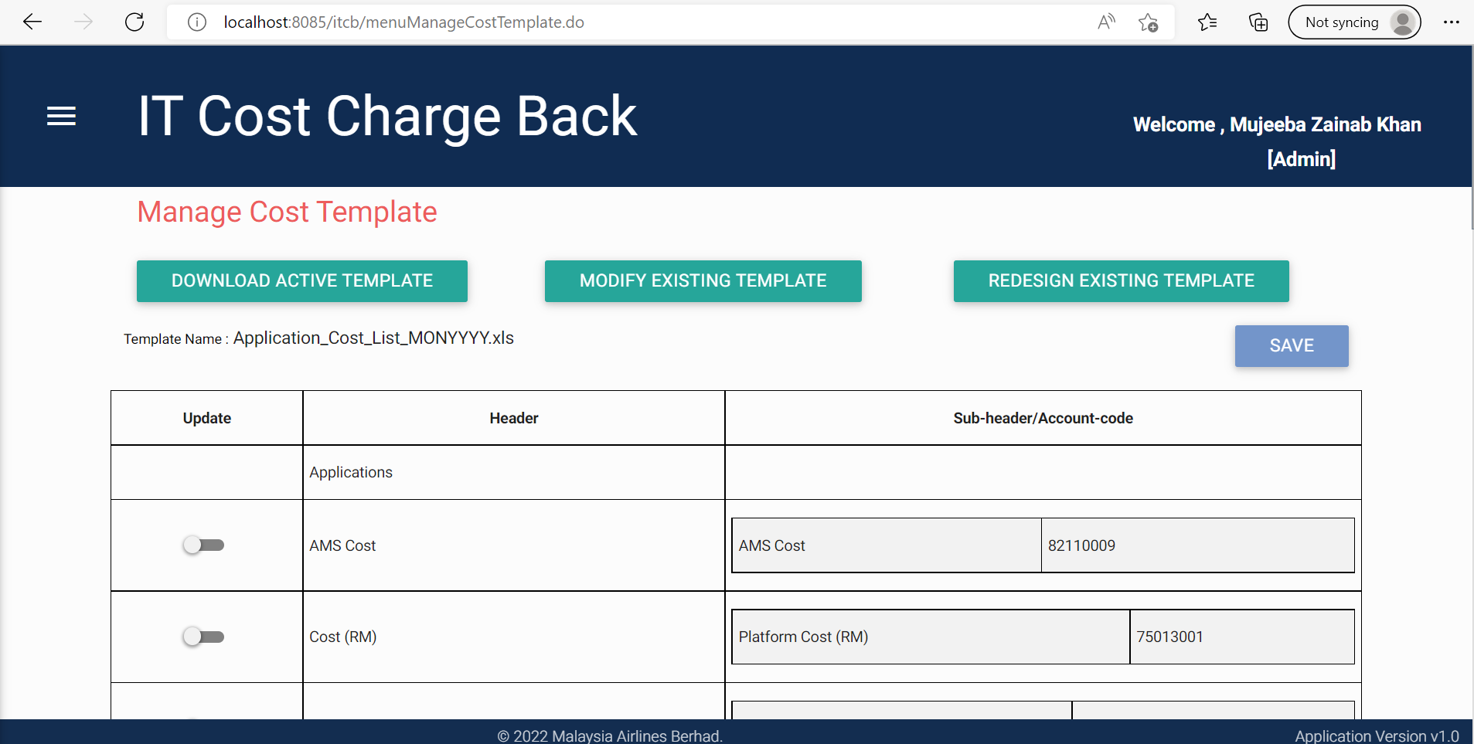

* Application Management

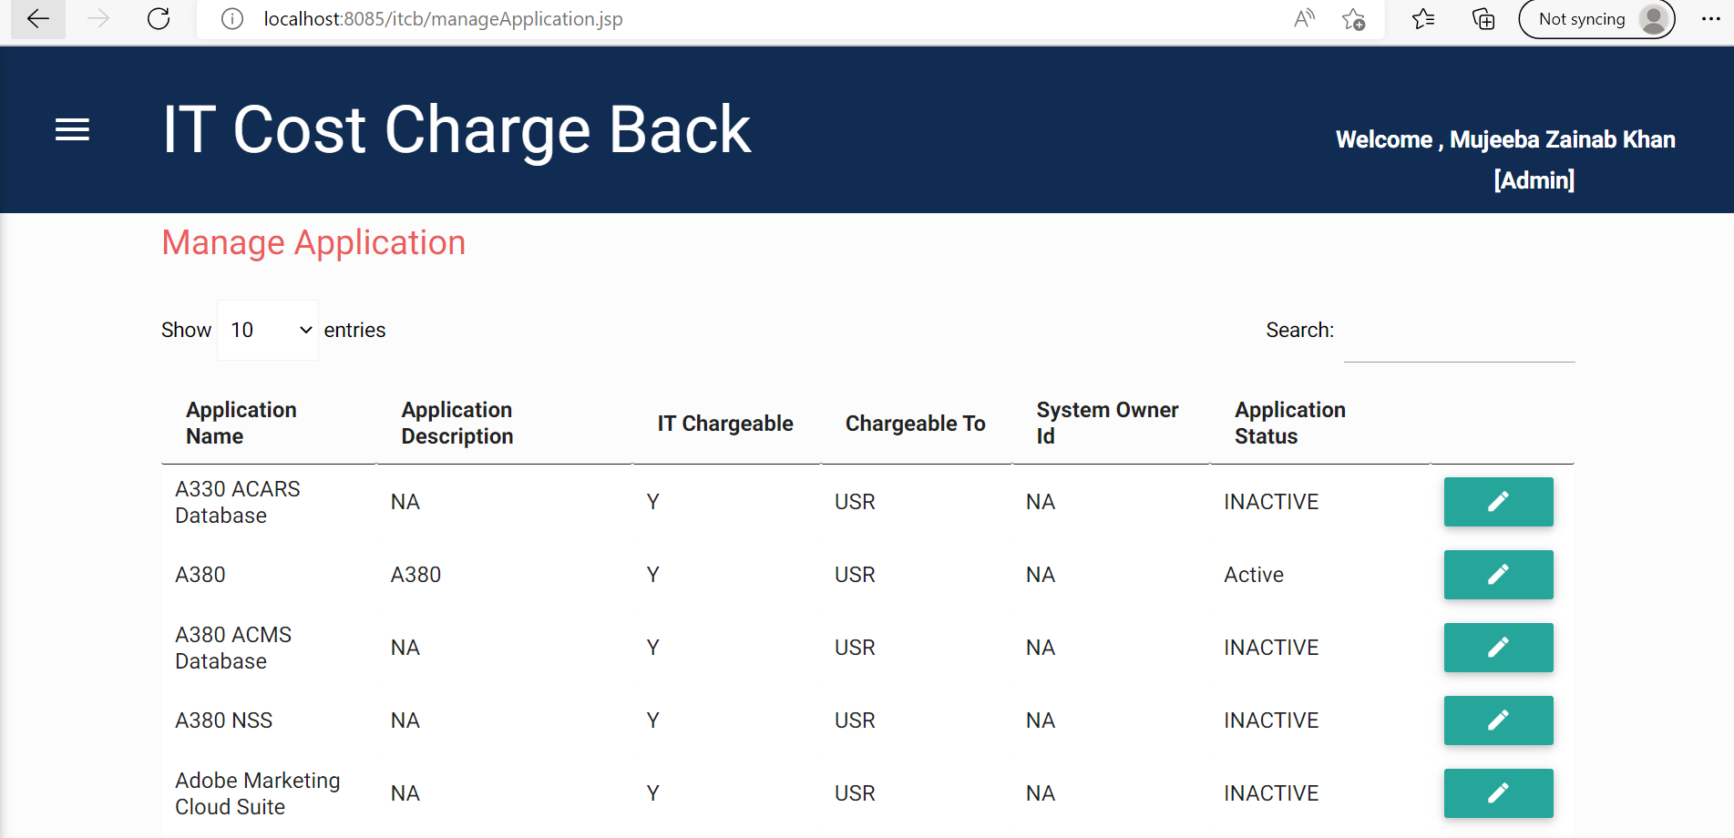

* Account Code Based Cost - Report

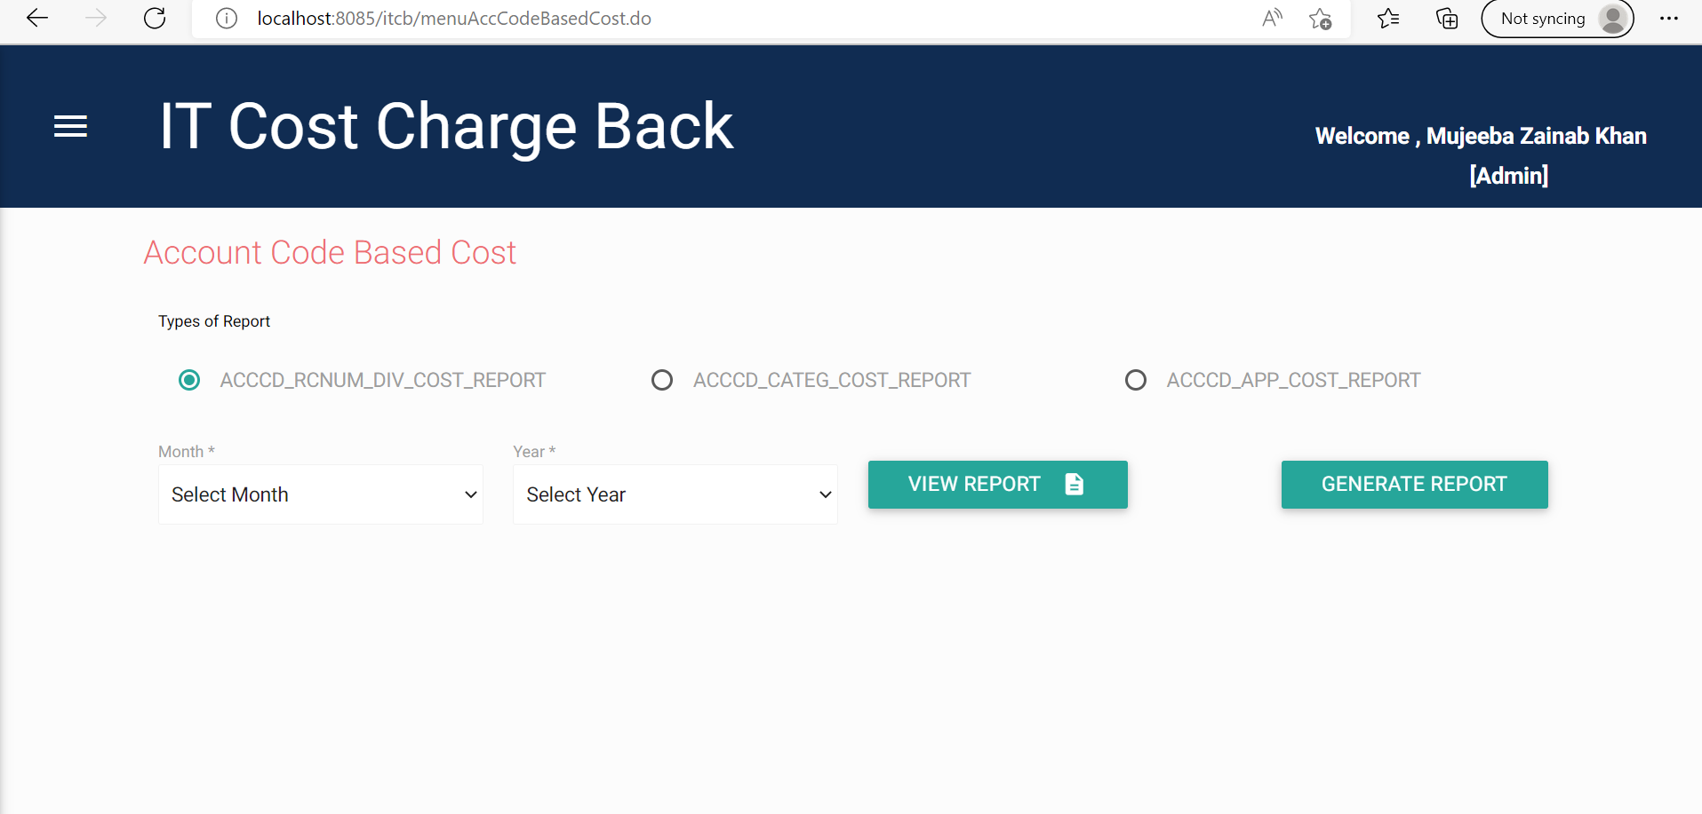

* Application Cost Loader

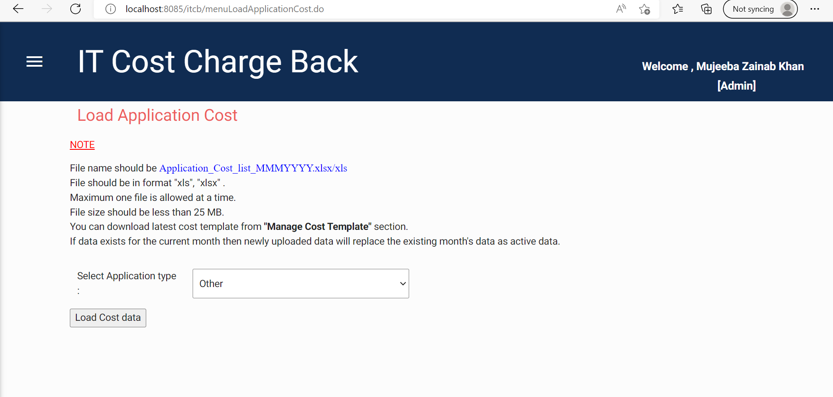

* Verify the log - Check for any unexpected error.

Check the logs at this path-

**logpath -** D://logs2/ITCB/ITCB_Log

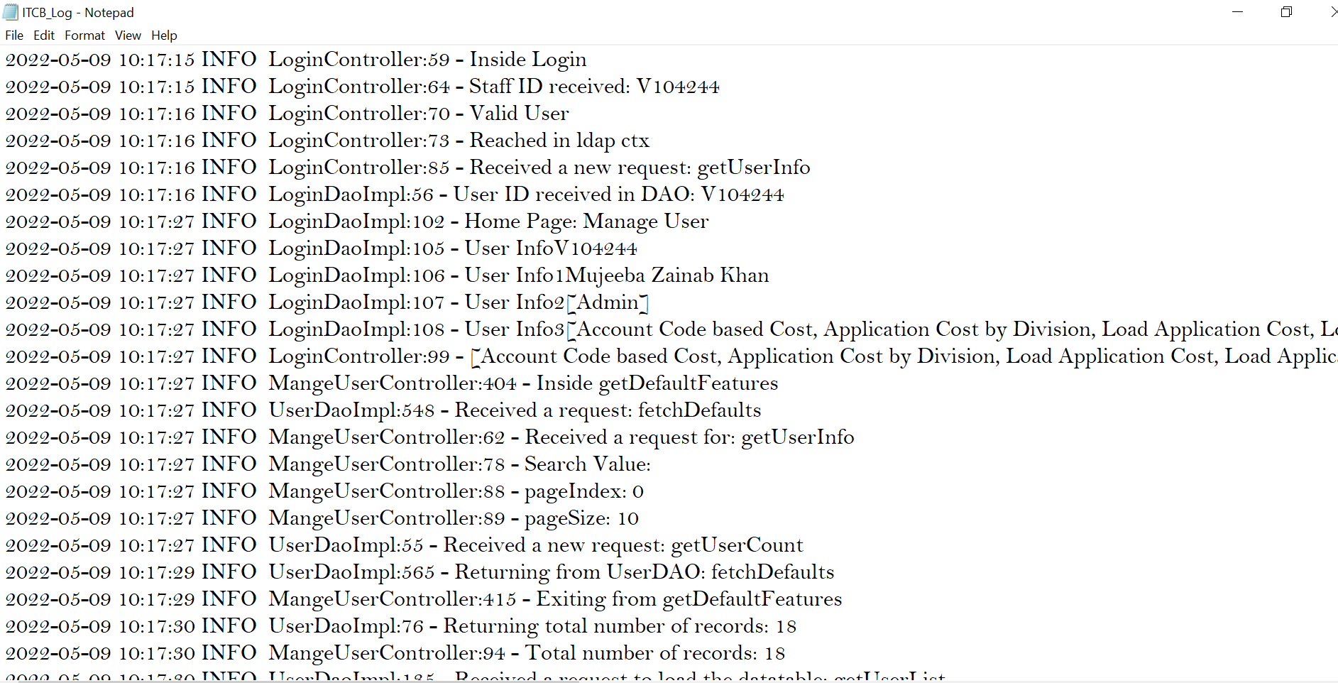

As we have validated the application and it is working fine, we can confirm the changes.